A* Search Algorithm

Aim:
To implement the A (A-Star) Search Algorithm* in Python to find the shortest path between a start node and a goal node using the actual cost and estimated cost.

Objective:
- To understand the concept of the A* Search Algorithm.
- To find the optimal path from a start node to a goal node.
- To use g(n) and h(n) values to calculate the total cost.
- To implement A* Search using Python.

Algorithm:
- Start with the initial node.
- Add the start node to the open list.
- Select the node with the lowest f(n) value.
- If the selected node is the goal, stop and display the path.
- Otherwise, expand its neighboring nodes.
- Calculate g(n), h(n) and f(n) for each neighbor.
- Add the unvisited neighbors to the open list.
- Repeat until the goal is reached.
Flow Chart:
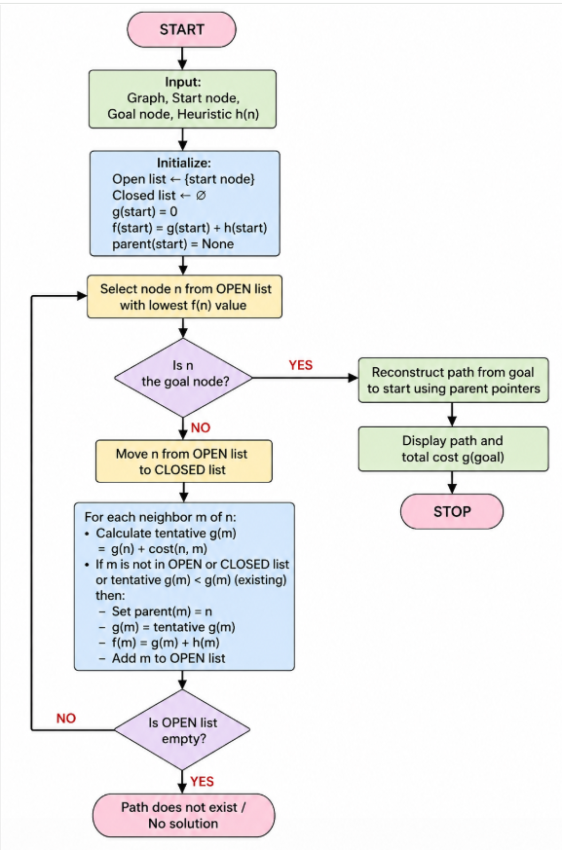
Code:
import heapq

graph = {
'A': {'B': 1, 'C': 4},
'B': {'D': 2, 'E': 5},
'C': {'E': 1},
'D': {'G': 3},
'E': {'G': 2},
'G': {}
}

heuristic = {
'A': 7,
'B': 6,
'C': 4,
'D': 3,
'E': 2,
'G': 0
}

def a_star(start, goal):
open_list = [(heuristic[start], 0, start)]
parent = {start: None}
cost = {start: 0}

while open_list:
f, g, current = heapq.heappop(open_list)

if current == goal:
path = []
while current is not None:
path.append(current)
current = parent[current]
path.reverse()
return path, g

for neighbor, edge_cost in graph[current].items():
new_cost = g + edge_cost

if neighbor not in cost or new_cost < cost[neighbor]:
cost[neighbor] = new_cost
parent[neighbor] = current
f_cost = new_cost + heuristic[neighbor]
heapq.heappush(open_list, (f_cost, new_cost, neighbor))

return None, None

start = 'A'
goal = 'G'

path, total_cost = a_star(start, goal)

if path:
print("Shortest Path:", " -> ".join(path))
print("Total Cost:", total_cost)
else:
print("Path not found")
Output:
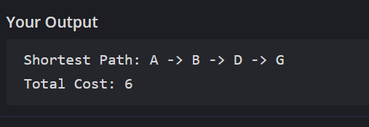
Result:
Thus, the A Search Algorithm* was successfully implemented in Python, and the shortest path from the start node A to the goal node G was found as:
A → B → D → G
with a total cost of 6.

